TASK:1
let studentName = "Sinduja"
let rollNumber: Int = 2301
var semester: Int = 5
var cgpa: Double = 8.02
let isHosteller: Bool = false
print("Name: \(studentName), Roll: \(rollNumber), Semester: \(semester)")
semester += 1
cgpa = 8.25
print("Name: \(studentName), Semester: \(semester), CGPA: \(cgpa)")
print(type(of: studentName))
print(type(of: rollNumber))
print(type(of: semester))
print(type(of: cgpa))
print(type(of: isHosteller))
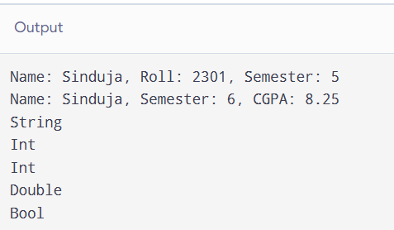
TASK:2
import Foundation
var celsius: Double = 25.0
let fahrenheitFactor = 9.0 / 5.0
let fahrenheitOffset = 32.0
let kelvinOffset = 273.15
print("Fahrenheit: \(String(format: "%.1f", celsius * fahrenheitFactor + fahrenheitOffset))")
print("Kelvin: \(String(format: "%.1f", celsius + kelvinOffset))")
celsius = 30.0
print("Fahrenheit: \(String(format: "%.1f", celsius * fahrenheitFactor + fahrenheitOffset))")
print("Kelvin: \(String(format: "%.1f", celsius + kelvinOffset))")

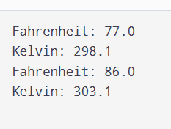
TASK 3:
Error
let price = 300 var price = 250
let total = price * quantity * taxRate let total = Double(price * quantity) * (1 + taxRate)
title = 42 title = "New Order"
var price = 250
var quantity: Int = 3
let taxRate = 0.18
price = 300
let total = Double(price * quantity) * (1 + taxRate)
var title = "Order"
title = "New Order"

print(total)
